1/3/21

Welcome, dear reader, to ‘The Treatment Room’ Acupuncture/Acupressure Point of the Week!

In association with, Tai Chi Your Way, www.taichiyourway.com

This week, we shall review the Acupuncture & Acupressure point, Ren-17,
(Aka CV-17, or put more simply, ‘The Sea of Tranquillity at the Middle of the Chest’!) See the photo below for the point location.

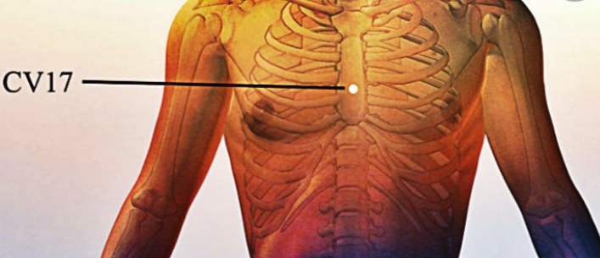

In the view of Traditional Chinese Medicine (aka TCM), emotions create palpable reactions inside of us. Sometimes these reactions are subtle and they pass unrecognised, and sometimes, they are obvious and unmistakeable, as the feeling described as ‘butterflies in your tummy’!

In particular, our varied emotional reactions to our life situations generate various internal energetic movements, regardless of whether or not our emotions are outwardly expressed, and resolved, or internally repressed, and denied.

More importantly, however, each of our emotional reactions causes a swell of our energy to move in very different directions within our bodies. Sadness, for example, feels heavy, and its energy sinks deeply within us, bringing us down. As it does so, it usually takes with it the power of our voice. It also causes the supportive energy from the core of our body to begin collapsing too. Hence, we buckle as the wind leaves our proverbial sails, and we slump, as our body loses its upright and optimistic posture.

Joy, however, causes movement in quite the opposite direction within us. Upon experiencing Joy, we begin to feel light and airy. Joy causes us to feel elated and uplifted. Upon feeling Joy, we stir, and rise upwards. We feel lighter, more capable, and we stand taller. Often, it shines forth from within us, beaming outward radiantly, as it often does in content babies.

Of course, you knew this already. You’ve felt this going on inside of you for years. However, what you may not know is that these emotional energies can congregate within different parts of our anatomy, and this congregation can cause us real problems down the line, especially when these parts of our anatomy begin to get overcrowded.

For example, the Qi (aka energy) of anxiety and stress races electrifyingly upwards in our bodies. Hence the common phrase, “I’ve had it up to here with you, Stuart!” (This is usually said, whilst we point one hand at our temples and the other at the perceived offender). Put simply, this means that anything, anyone or any event that stresses us, causes nervous energy to flood upwards toward our head, neck, shoulders. Ultimately, it then gathers around our Heart and chest. Overtime, this energy can accumulate to troubling and bubbling levels. With layer after layer arriving, as event after event occurs, these emotional energies can coagulate, and as our Qi thickens in this region, unless we are clearing these energies regularly, we will soon feel a sense of internal pressure building. We might even say, “I feel under pressure”, or “I don’t feel right in myself”, or “this small event is really getting to me.”

If varying and particularly negative emotional states are left unaddressed, soon there won’t be a lot of wiggle room left in the tissues surrounding our organs. This is when we often start to feel volatile, or snappy or stiff, heavy, oppressed and sluggish. When this happens, we begin losing our suppleness and mobility, mentally, as well as physically.

Of course, with what’s going on around us at present, many of us could be forgiven for feeling anything other than stressed, anxious, panicked, frustrated or even fearful by times. Experiencing any, or indeed all of these feelings, would hardly be surprising in today’s climate, for the winds of change have conspired to blow substantial fears, worries and troubles our way.

To alleviate this, however, we can turn to self-care, and in this case, to Ren-17, (aka CV-17) an Acupuncture Point, literally in the middle of our chest. In TCM, each Acupuncture point has a primary job, or a set of functions as it were, and this point has the very important jobs of helping energy descend, as well as loosening, opening and unbinding our chests. These important actions help us to calm down, and to decompress by gradually clearing our Hearts of tension and accumulated negativities. This is a very soothing point.

As a result, this Acupuncture point is very useful for helping us to release anxiety, fear, panic and even sorrow. Stimulating this point regularly can gradually help dissolve a feeling of ‘heaviness’ weighing upon our chests. This point is also useful for helping us gather more air. In clinical treatment, it’s often used in treating asthma, shortness of breath, or the type of shallow breathing that regularly accompanies panic.

To find this Acupuncture point you will need to find your breast bone, or your sternum. Please see the diagram just below, for reference. Your sternum is in the middle of your chest, just beneath where a man’s tie would hang. First, put your finger on your breast bone, and then walk it gently down to the tip of your sternum, which is called the xiphoid process (pronounced zif-oid). Feel free to bring this up at dinner, if you want to sound fancy!

Your xiphoid process is just above your middle abdomen. Don’t forget to take a peek at the accompanying photo below for clarity on this. Now, don’t press hard on your xiphoid process, it’s just a marker for us to find this point.

Next, place your little pinkie on the end or tip of your xiphoid process, and with all 4 of your fingers neatly stacked atop and touching each other, the point you are looking for is under your index finger. So, it’s four finger widths up from the tip of your xiphoid process. You ought to feel a groove here, not unlike a wee depression. Now, put your middle finger tip on this point and hold it here gently for two minutes.

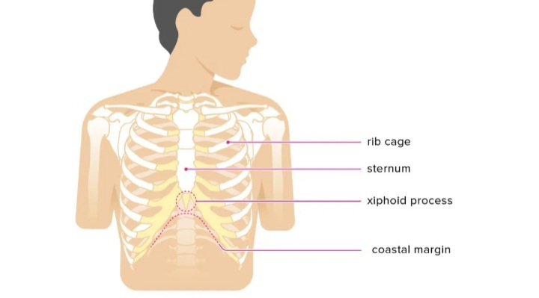

This will activate the point. If you want a stronger reaction, you can friction the point from side to side, or rotate your finger here in a circle, dragging the skin as you do.

However, please don’t beat the bejesus out of yourself here. If you work this point too vigorously, you will bruise and ache, and you will definitely experience soreness here. However, if you’re ok with that, then work away. By the way, soreness here, upon barely touching the point, is not uncommon.

Personally I like to hold this point, while lying down. I then close my eyes and gently focus on the sensation of my middle finger tip settling into the point. I allow the point to do its job while I concentrate on my breathing. After a fashion, I then slowly remove my finger from the point, and enjoy feeling calmer afterwards.

Enjoy!

P.S. Do not try this while driving or while in water!

The Treatment Room is accredited by The Acupuncture Foundation Professional Association. (AFPA Membership number: 8556) & by The Irish T’ai Chi Chuan Association (ITCCA).

Best wishes,
Chris Mc Mahon,
The Treatment Room.

